SUBMISSION REPORT OF Course-end Project 1

Project name: AWS Technical Essentials Project – Server Monitoring

Heaven Classics – AWS EC2 Instance Setup & Monitoring Report
Date: December 19, 2025
Project Title: EC2 Windows Server Deployment and Monitoring
Prepared For: Heaven Classics Support & Monitoring Team

📑 Consolidated Project Report
Project: AWS EC2 Instance Setup & Monitoring Company: Heaven Classics Server: Windows 2012 Server on Amazon EC2 Monitoring Tool: AWS CloudWatch

🛠 Project Overview
Heaven Classics successfully launched an EC2 instance running Windows Server 2012. To ensure smooth operations, the monitoring team implemented AWS CloudWatch for performance tracking and alerting. Additionally, IAM configurations were set up to manage administrative access securely.

📊 Step-by-Step Completion Demo
- Launch EC2 Instance

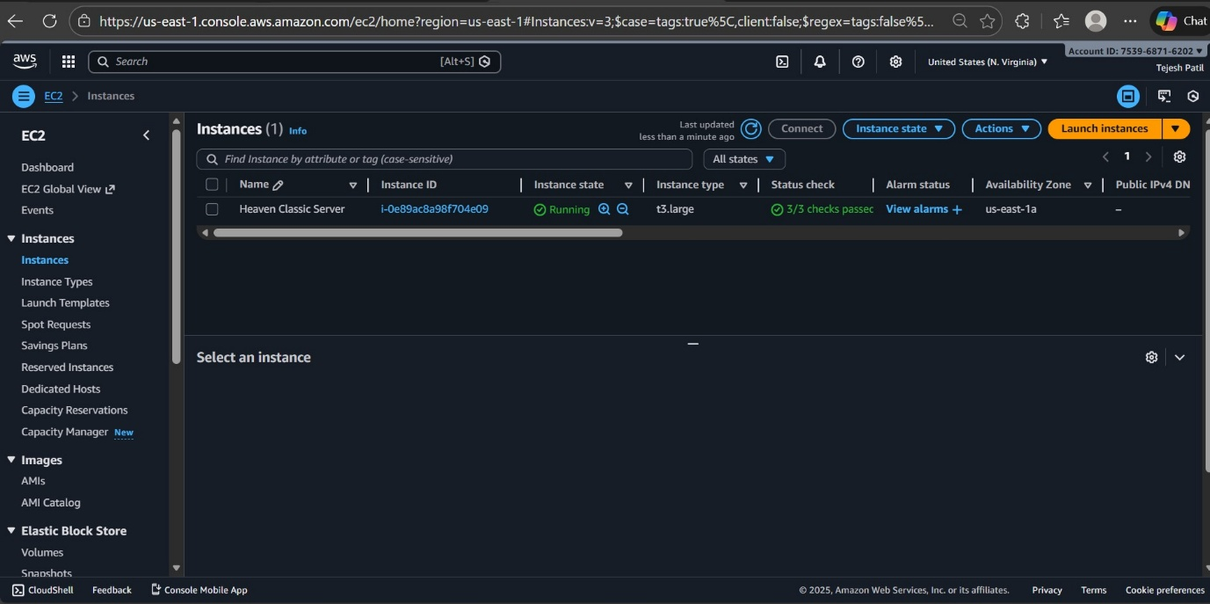

- CPU Utilization Graph

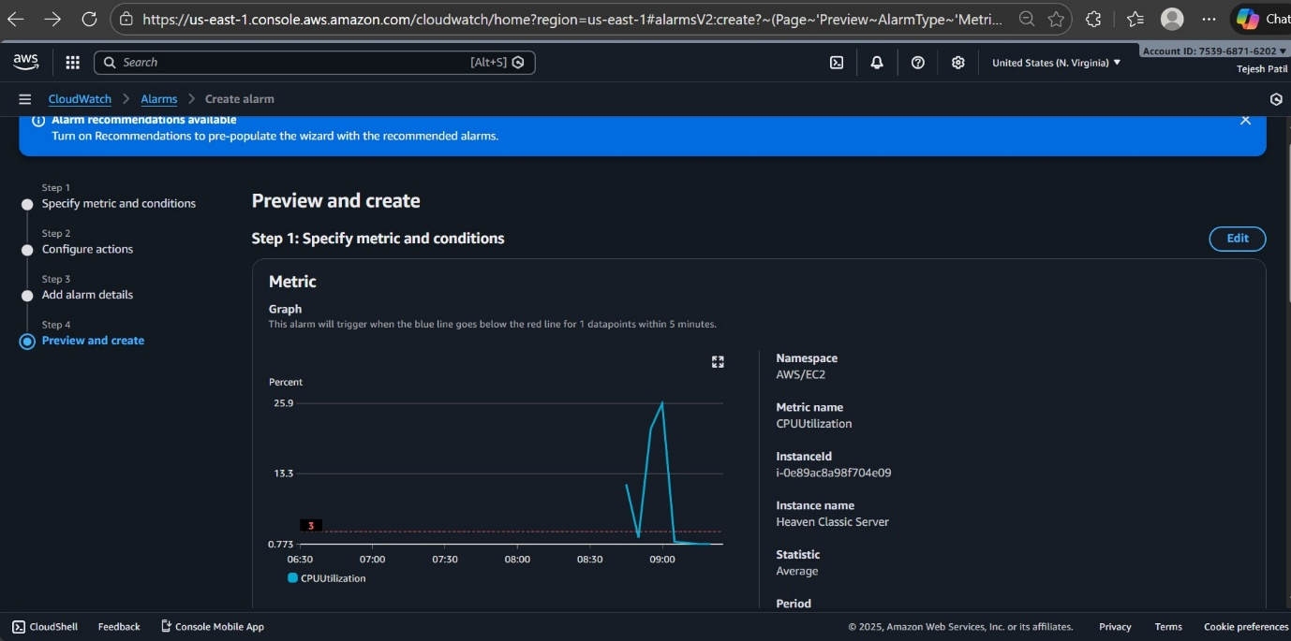

- Configure CloudWatch Alarm

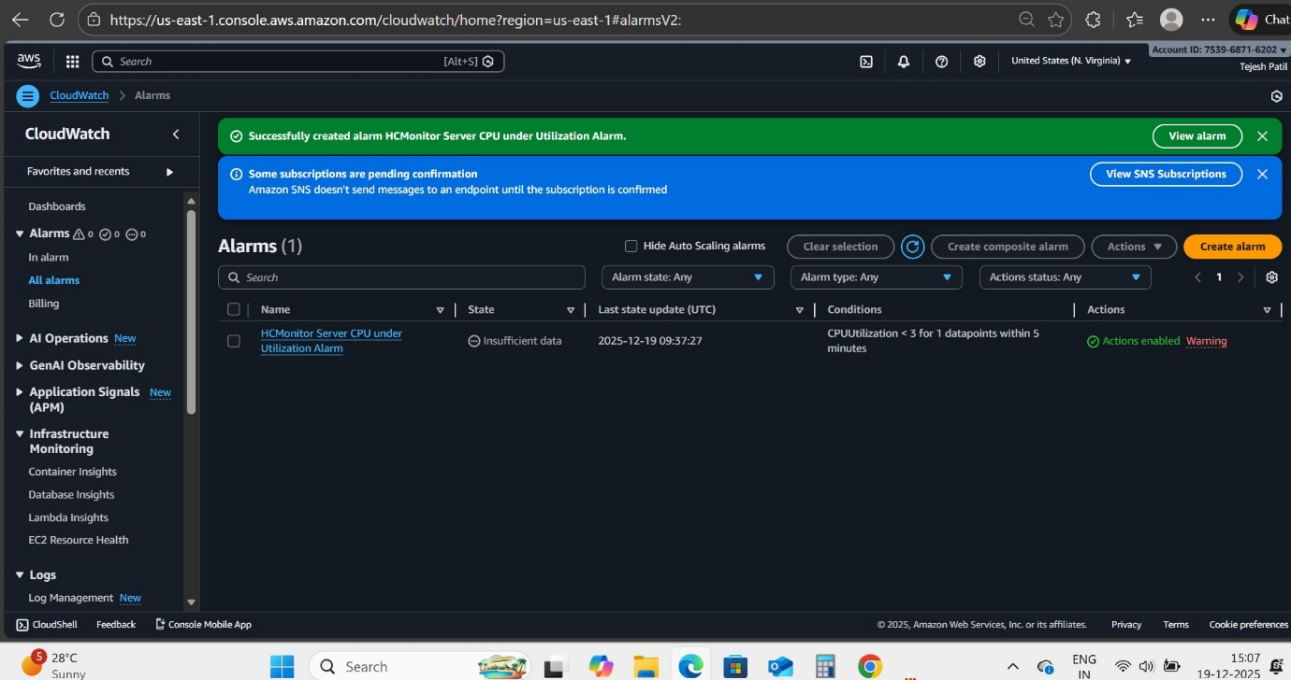
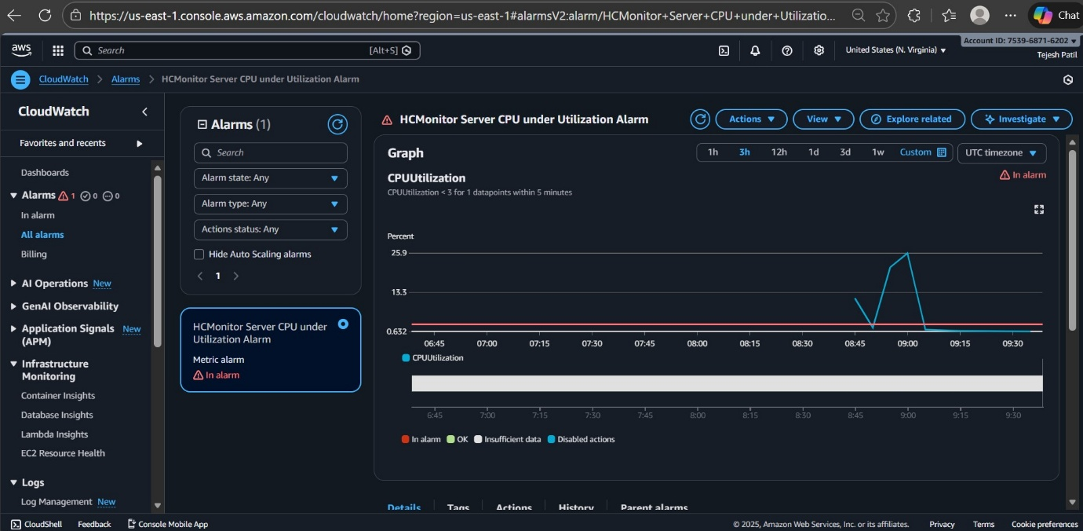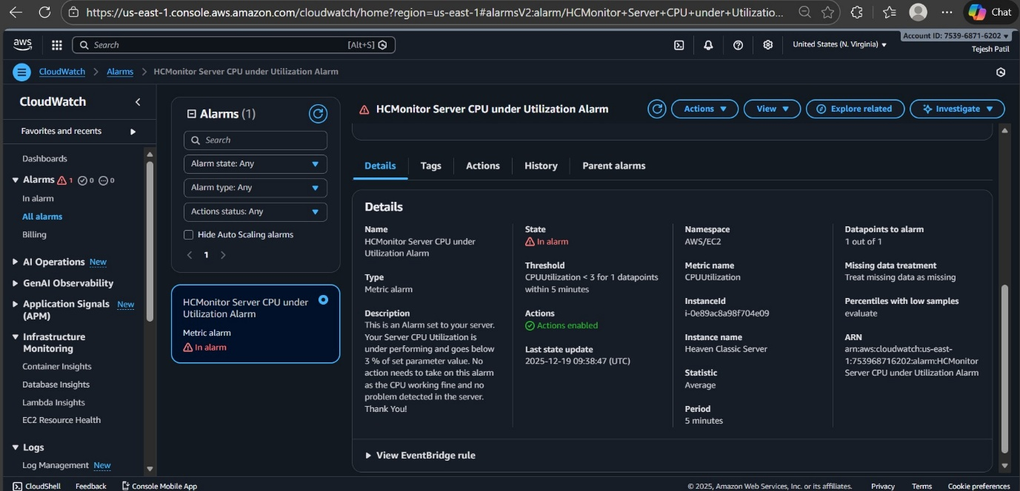

- Notification Setup (Amazon SNS)
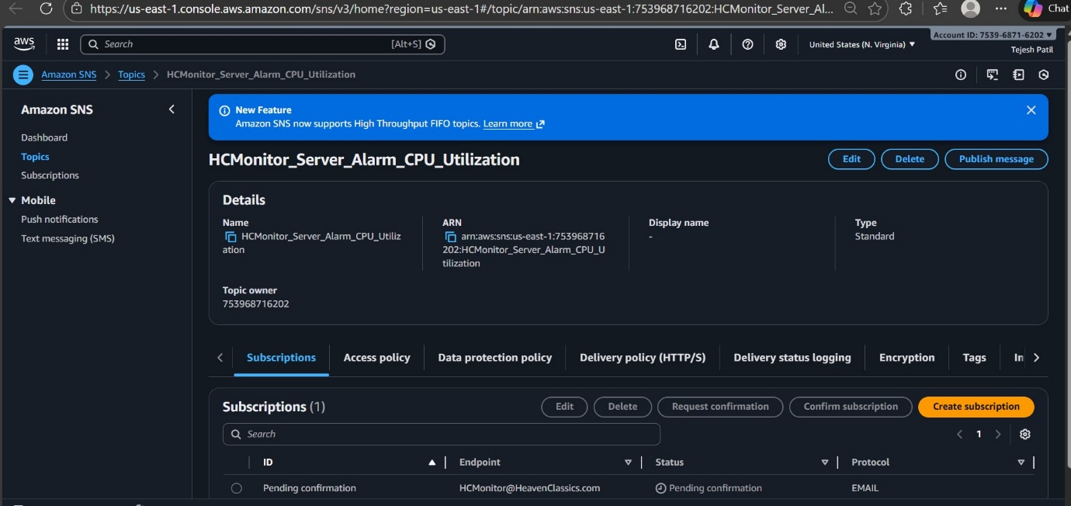
- Create IAM Group & Attach Policy

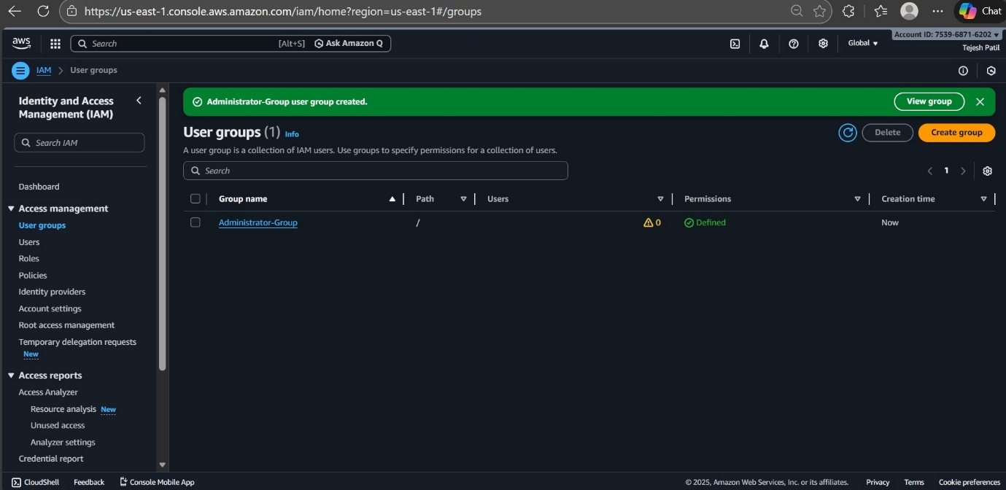

- Create IAM User & Add User to Group

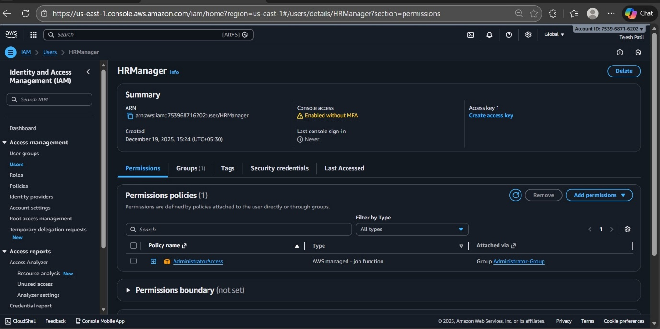

📊 Step-by-Step Completion Table

Step No. | Task | Action Taken | Completion Status
1 | Launch EC2 Instance | Created Windows 2022 Server EC2 instance | ✅ Completed
2 | Monitor Operations | Enabled monitoring via AWS CloudWatch | ✅ Completed
3 | CPU Utilization Graph | Checked and observed CPU utilization metrics in CloudWatch | ✅ Completed
4 | Configure CloudWatch Alarm | Alarm created to trigger if CPU utilization < 3% for 3 consecutive checks over 5 minutes | ✅ Completed
5 | Notification Setup | Configured SNS to send email alerts to HCMonitor@HeavenClassics.com | ✅ Completed
6 | Create IAM Group | Created Administrator Group in IAM | ✅ Completed
7 | Attach Policy | Attached AdministratorAccess policy to the group | ✅ Completed
8 | Create IAM User | Created IAM user for employee requiring admin access | ✅ Completed
9 | Add User to Group | Added IAM user to Administrator Group | ✅ Completed

📌 Key Highlights
- Monitoring: CloudWatch enabled for real-time performance tracking.
- Alerting: Automated email notifications ensure proactive response to low CPU utilization.
- Security: IAM group and user setup ensures controlled and secure access to AWS resources.
- Compliance: All objectives defined by the support team were successfully achieved.

✅ Project Workflow

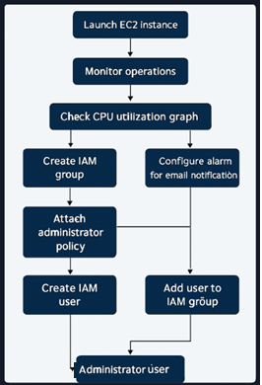

✅ Final Status
The project objectives were successfully completed. Heaven Classics now has:
- A running EC2 Windows 2012 Server instance.
- Active monitoring and alerting via AWS CloudWatch service.
- Secure IAM configurations for administrator access.

Thanks, with regards
Tejesh Namdev Patil
9673381152

